SIMATS ENGINEERING (SAVEETHA SCHOOL OF ENGINEERING)
Department of Computer Science and Engineering
CO2 ASSESSMENT TOOL 1 – Scenario-Based Requirement Analysis

Course Code: | CSA10 / CSA1005 | Course Title: | Software Engineering
CO Assessed: | CO2 | Assessment: | Assessment Tool 2 – Scenario-Based Requirement Analysis
Weightage: | 20% | Total Marks: | 25
CO2 Statement: | Perform detailed requirements analysis, design scalable architectures, and prioritize features with a focus on cross-disciplinary skills
Student Name: | ALAN ALDRIN | Reg. No.: | 192411023
Date: | 27.10.26 | Duration: | 60 minutes

Code of Conduct
I __________ALAN ALDRIN E.A_(192411023)_______________ (Name / Reg No) certify that this submission is my original work and that I have adhered to the guidelines specified for this assessment. I understand that any violation of academic integrity rules will result in disciplinary action.
Signature of the Student: ______ALAN ALDRIN___________________
Annexure A – Scenario-Based Requirement Analysis
Instructions to Students:
Each student will be assigned an individual software project problem statement. Analyze the given scenario and prepare a complete Software Requirement Analysis document by following the steps below.

Question
Based on the assigned problem statement, perform a Scenario-Based Requirement Analysis and prepare a Software Requirement Specification (SRS) document. Your analysis should include the following:
- Study and Analyze the Scenario
  - Carefully understand the given problem statement.
  - Identify the business domain, stakeholders, existing challenges, and system objectives.
- Identify Functional and Non-Functional Requirements
  - List all functional requirements required by the proposed system.
  - Identify suitable non-functional requirements such as performance, security, reliability, usability, scalability, maintainability, and availability.
- Identify Actors and Use Cases
  - Identify all primary and secondary actors interacting with the system.
  - List the major use cases associated with each actor.
  - Draw a Use Case Diagram representing the interactions between actors and the system.
- Prepare the Software Requirement Specification (SRS)
Develop an SRS document containing:
  - Introduction
  - Problem Description
  - Scope of the System
  - Functional Requirements
  - Non-Functional Requirements
  - Use Case Descriptions
  - Data Requirements
  - External Interface Requirements
  - System Features
- Identify Assumptions and Constraints
  - List the assumptions considered while developing the system.
  - Identify technical, operational, economic, legal, and time-related constraints affecting the project.
- Validate Requirement Completeness and Consistency
  - Verify whether all stakeholder requirements have been addressed.
  - Check for ambiguity, redundancy, inconsistency, and missing requirements.
  - Suggest improvements to enhance the quality and completeness of the requirement specification.
Rubrics for Calculation
Criteria | Excellent (4 Marks) | Good (3 Marks) | Satisfactory (2 Marks) | Needs Improvement (1 Mark)
Scenario Understanding and Problem Analysis (30%) | Demonstrates thorough understanding of the scenario, stakeholders, objectives, and business context with clear analysis. | Demonstrates good understanding with minor omissions. | Basic understanding with limited analysis. | Poor understanding; major aspects missing or incorrect.
Functional and Non-Functional Requirement Identification (25%) | Clearly identifies comprehensive, accurate, and well-classified functional and non-functional requirements. | Identifies most requirements with minor classification errors. | Identifies only basic requirements; several omissions. | Requirements are incomplete, inaccurate, or poorly classified.
Actor Identification and Use Case Modelling (20%) | Correctly identifies all relevant actors and use cases; use case diagram is complete, accurate, and follows UML standards. | Most actors and use cases identified; diagram has minor errors. | Limited actors/use cases identified; diagram partially correct. | Actors/use cases missing or incorrect; diagram absent or inaccurate.
Software Requirement Specification (SRS) Documentation (15%) | SRS is well-structured, complete, professionally organized, and includes all required sections. | SRS is organized with minor missing sections or formatting issues. | SRS includes only essential sections with limited detail. | SRS is incomplete, poorly organized, or lacks essential components.
Assumptions, Constraints, and Requirement Validation (10%) | Clearly identifies realistic assumptions and constraints; validates requirements for completeness, consistency, and ambiguity with appropriate justification. | Identifies most assumptions and constraints; validation is adequate. | Limited assumptions/constraints; validation is superficial. | Assumptions, constraints, and validation are missing or incorrect.

Criteria | Mark
Scenario Understanding and Problem Analysis (30%) | /5
Functional and Non-Functional Requirement Identification (25%) | /5
Actor Identification and Use Case Modelling (20%) | /5
Software Requirement Specification (SRS) Documentation (15%) | /5
Assumptions, Constraints, and Requirement Validation (10%) | /5
TOTAL | /25

Software Requirement Specification (SRS)
Digital Asset Management System for Creative Organizations (DAMS)
1. Introduction
Purpose: this SRS defines what the Digital Asset Management System (DAMS) must do. DAMS is a secure web platform where creative teams upload, classify, search, version, share, approve and archive digital assets (images, video, audio, designs, documents, marketing material). Audience: developers, testers, project managers, asset managers, administrators, and the evaluator.
Key terms: Asset = any stored digital file; Metadata = descriptive data about an asset (title, tags, rights, campaign); Version = a numbered revision of an asset; Approval workflow = a review path an asset passes before release; RBAC = Role-Based Access Control; Archive = removal from active use while retaining the record; FR/NFR = Functional/Non-Functional Requirement. References: IEEE 830-1998, ISO/IEC/IEEE 29148:2018.
2. Scenario Analysis and Problem Description
Domain: content and media management for media organizations, advertising agencies, educational institutions and creative teams that hold large collections of images, videos, audio, designs and marketing documents.
Stakeholder | Interest in the system
Creators / contributors | Easy upload, tagging and versioning of their work
Team members / marketers | Find the right, current asset quickly and use it safely
Reviewers / brand managers | Controlled approval so only approved content is published
Asset manager / librarian | Organisation, taxonomy, archiving, usage insight
Administrator | Users, roles, permissions, storage and audit control
External agencies / clients | Limited, secure access to shared assets
Management / legal | Governance, licence compliance, reduced unauthorised use

Existing challenges
• Assets are scattered across drives and inboxes with inconsistent names, so they are hard to find.
• Little or no metadata, so search is poor and duplicates are common.
• Outdated or unapproved versions get used because versions and approvals are not tracked.
• No record of who used an asset where, who changed it, or who shared it; unauthorised use and expired licences go unnoticed.
• Obsolete assets clutter storage and no standard archive process exists.
System objectives: (1) upload and organise assets, (2) maintain metadata, (3) advanced search, (4) version control, (5) manage access permissions, (6) approval workflows, (7) track asset usage, (8) audit trails, (9) archive obsolete assets, (10) generate reports. Expected outcomes: faster retrieval, less duplicate content, better organisation, improved collaboration, reduced unauthorised usage and better content governance.
3. Scope of the System
In scope: bulk upload with duplicate detection; automatic and manual metadata; categories, collections and tags; full-text and metadata search with filters; version history and restore; role-based permissions per folder and asset; configurable approval workflows; secure share links with expiry; usage tracking of views, downloads and campaign use; audit trail; archive and retention; dashboards and reports; notifications.
Out of scope: creating or editing media inside the system (image/video editors); social-media publishing; billing and licence payments; AI content generation; hardware and storage-infrastructure manufacturing.
4. Functional Requirements
Priority (MoSCoW): M = Must, S = Should, C = Could.
ID | Module | Requirement | Pri.
FR-01 | Upload | Upload single or multiple files (images, video, audio, design files, documents) with progress and size/type validation. | M
FR-02 | Upload | Detect duplicate or near-duplicate files by checksum and warn before saving. | M
FR-03 | Organisation | Organise assets in folders, collections and categories under a managed taxonomy. | M
FR-04 | Metadata | Capture mandatory metadata (title, description, tags, owner, campaign, usage rights, expiry date) and extract technical metadata (format, size, dimensions, duration). | M
FR-05 | Metadata | Edit metadata singly or in bulk; keep every change in history. | S
FR-06 | Search | Keyword search across names, metadata and document text, with ranking. | M
FR-07 | Search | Filter by type, tag, category, owner, date, status, rights and campaign; save frequent searches. | M
FR-08 | Search | Show previews and thumbnails in results. | S
FR-09 | Versioning | Store every upload to an existing asset as a new numbered version with a change note. | M
FR-10 | Versioning | View version history, compare, restore an earlier version; only the approved version is marked current. | M
FR-11 | Access control | Authenticate users (password or SSO) and assign roles: Admin, Asset Manager, Reviewer, Contributor, Team Member, External Collaborator. | M
FR-12 | Access control | Restrict view, download, edit, share and delete rights by role, folder and asset. | M
FR-13 | Workflow | Submit an asset for approval; route it to one or more reviewers per the configured workflow. | M
FR-14 | Workflow | Reviewers approve, reject or request changes with comments; status is visible to the contributor. | M
FR-15 | Workflow | Asset Manager configures workflows (stages, reviewers, deadlines) per asset type or folder. | S
FR-16 | Workflow | Block publishing or sharing of assets that are not approved. | M
FR-17 | Sharing | Create secure share links with expiry, password and download limit; revoke any time. | M
FR-18 | Usage tracking | Record every view, download, share and use of an asset by user, time and purpose or campaign. | M
FR-19 | Usage tracking | Show where and how often an asset was used; flag assets used after rights expiry. | S
FR-20 | Audit | Write an immutable audit trail of uploads, edits, approvals, permission changes, shares, deletions and logins. | M
FR-21 | Archive | Archive obsolete or expired assets manually or by rule; archived assets leave normal search but can be restored. | M
FR-22 | Archive | Apply retention rules and warn owners before assets expire. | S
FR-23 | Reports | Reports on uploads, storage, popular and unused assets, duplicates found, approvals pending, usage and audit; export to PDF and CSV. | M
FR-24 | Notifications | Notify users of approval requests, decisions, expiring rights and shared-link activity. | S
FR-25 | Administration | Manage users, roles, taxonomy, storage quotas and system settings. | M
FR-26 | Integration | Provide an API and connectors for creative tools and storage services. | C

5. Non-Functional Requirements
Figures are proposed targets to be confirmed with stakeholders.
ID | Category | Requirement
NFR-01 | Performance | Search results within 2 s for 95% of queries on a library of 1 million assets; pages load within 3 s; thumbnails generated within 10 s of upload.
NFR-02 | Scalability / capacity | Support at least 500 concurrent users and large uploads (files up to several GB); storage and users scale horizontally without redesign.
NFR-03 | Security | TLS 1.2+; files and sensitive metadata encrypted at rest; RBAC checked on every request; MFA for privileged roles; virus scan on upload; signed, expiring download links.
NFR-04 | Reliability | No loss of assets or versions; daily backups with tested restore; resumable uploads after network failure.
NFR-05 | Availability | 99.5% uptime outside planned maintenance.
NFR-06 | Usability | New users can upload and tag an asset after short guidance; drag-and-drop upload; responsive and WCAG 2.1 AA accessible.
NFR-07 | Maintainability | Modular, documented code with automated tests; metadata schema, workflows and retention rules configurable without code changes.
NFR-08 | Compatibility | Current Chrome, Edge, Firefox, Safari; common file formats with preview support.
NFR-09 | Auditability / compliance | Tamper-evident logs, retained per policy; respects licence and data-protection obligations.
NFR-10 | Interoperability | REST API and standard metadata formats (for example IPTC/XMP) for import and export.

6. Actors and Use Cases
Actor | Type | Major use cases
Contributor | Primary | Upload assets; edit metadata; manage versions; submit for approval
Team Member | Primary | Search and filter; preview and download; share asset by link
External Collaborator | Primary | Access shared assets through a secure link
Reviewer | Primary | Review asset; approve or reject asset
Asset Manager | Primary | Manage taxonomy; configure workflow; archive obsolete assets; track usage; generate reports
Administrator | Primary | Manage users and permissions; view audit trail; generate reports
Storage Service | Secondary | Stores and serves asset files and versions
Notification Service | Secondary | Delivers email and in-app notifications

All users log in first (FR-11); this step is not drawn. Use case diagram (UML):
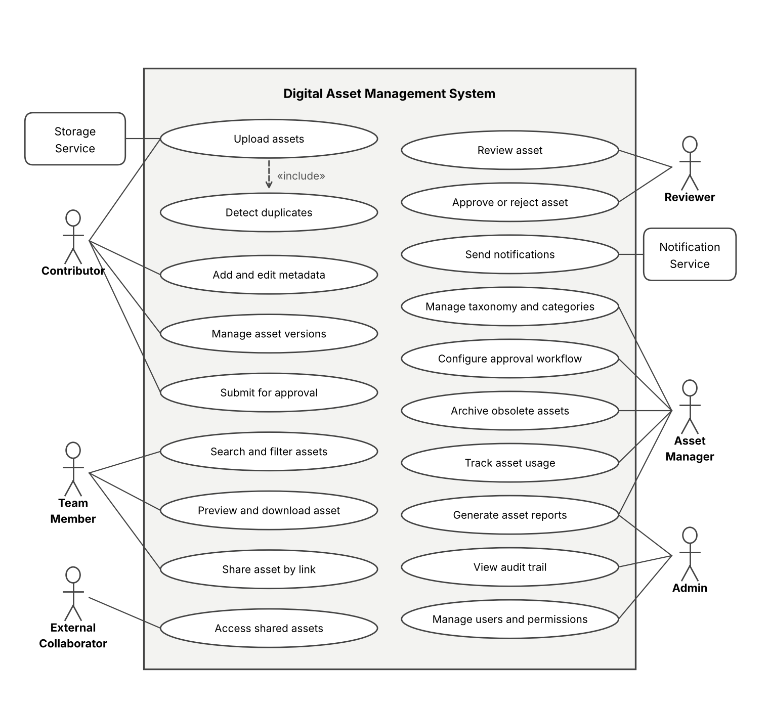
Figure 1: Use case diagram of DAMS
7. Use Case Descriptions
UC-01 Upload assets (includes Detect duplicates)
Field | Detail
Actors | Contributor (primary), Storage Service
Precondition | Contributor is logged in with upload permission
Main flow | 1. Contributor selects files and a destination folder. 2. System validates type, size and virus scan. 3. System checks for duplicates by checksum. 4. System stores the file, generates thumbnail and extracts technical metadata. 5. Contributor adds required metadata and saves.
Alternate flow | Duplicate found: user may cancel, link to the existing asset, or save as a new version. Invalid or infected file: rejected with a message.
Postcondition | Asset saved as Draft with version 1; audit entry written

UC-06 Search and filter assets
Field | Detail
Actors | Team Member (primary)
Precondition | User is logged in; results limited to assets the user may view
Main flow | 1. User enters keywords. 2. System searches names, metadata and text. 3. User applies filters (type, tag, owner, date, status, rights). 4. System shows ranked results with thumbnails. 5. User opens or downloads an asset.
Alternate flow | No result: system suggests related tags. Restricted asset: hidden from results.
Postcondition | Download or view is recorded in usage tracking

UC-05 / UC-11 Submit for approval, then approve or reject asset
Field | Detail
Actors | Contributor, Reviewer, Notification Service
Precondition | Asset is Draft with required metadata complete
Main flow | 1. Contributor submits the asset. 2. System routes it to the configured reviewer(s) and notifies them. 3. Reviewer opens the asset and approves. 4. System marks the version Approved and current, and notifies the contributor.
Alternate flow | Reviewer rejects or requests changes with comments: asset returns to Draft. No action by the deadline: reminder or escalation.
Postcondition | Asset is Approved and shareable, or returned for changes; decision logged

UC-08 Share asset by link / UC-09 Access shared assets
Field | Detail
Actors | Team Member; External Collaborator
Precondition | Asset is Approved and the user may share it
Main flow | 1. User creates a link with expiry, optional password and download limit. 2. System generates a signed link. 3. External collaborator opens the link and views or downloads. 4. System records the access.
Alternate flow | Link expired, revoked or limit reached: access denied and logged. Unapproved asset: link cannot be created.
Postcondition | Access is recorded in usage tracking and audit trail

UC-14 Archive obsolete assets
Field | Detail
Actors | Asset Manager (primary)
Precondition | Asset is obsolete, expired, or matches a retention rule
Main flow | 1. Manager selects assets or a rule. 2. System warns if the asset is still in use. 3. Manager confirms. 4. System moves the assets to Archived, removes them from normal search and revokes active share links.
Alternate flow | Restore: manager returns an archived asset to Active.
Postcondition | Assets archived; audit entry written; storage tier updated

8. Data Requirements
Entity | Key attributes | Relationships
User / Role | user_id (PK), name, email, password_hash or SSO id, role_id (FK), status | Many users to one role
Asset | asset_id (PK), title, type, owner_id (FK), category_id (FK), status (Draft, In Review, Approved, Archived), created_at, rights_expiry | One asset to many versions, tags, usage records
Asset Version | version_id (PK), asset_id (FK), version_no, file_path, checksum, size, change_note, created_by, created_at | Many versions per asset
Metadata / Tag | meta_id (PK), asset_id (FK), key, value; tag_id, tag_name | Many tags to many assets
Category / Collection | category_id (PK), name, parent_id, collection owner | Hierarchical; many assets
Permission | permission_id (PK), role_id or user_id, target (folder/asset), rights (view, download, edit, share, delete) | Applied to folders and assets
Approval Request | request_id (PK), asset_id, version_id, workflow_id, reviewer_id, status, comment, decided_at | One per review stage
Share Link | link_id (PK), asset_id, token, expires_at, password_hash, download_limit, status | Many links per asset
Usage Record | usage_id (PK), asset_id, user_id or link_id, action (view, download, share, use), campaign, timestamp | Many per asset
Audit Log | audit_id (PK), user_id, action, entity, entity_id, timestamp, ip_address | Written for sensitive actions
Notification | notif_id, recipient_id, type, message, sent_at, status | Linked to user and request

Data rules: versions, usage and audit records are append-only; checksums detect duplicates and corruption; files are stored encrypted and addressed by version; archived assets keep their metadata and history; retention periods are configurable.
9. External Interface Requirements
• User interfaces: responsive web application with drag-and-drop upload, grid and list views with thumbnails, an advanced search panel, an approval inbox, a version timeline, and dashboards for managers and administrators.
• Hardware interfaces: none required beyond standard client devices; server-side storage and processing for thumbnails and previews.
• Software interfaces: object/file storage service, relational database, search engine index, email service, identity provider (SSO), virus-scanning service, optional creative-tool plug-ins and external storage connectors.
• Communication interfaces: HTTPS (TLS 1.2+); REST/JSON API with token authentication; webhooks for approval and publishing events.
10. System Features
Feature | Stimulus and response | Requirements
Upload and organisation | User uploads files; system validates, deduplicates, stores and files them | FR-01 to 03
Metadata management | User edits metadata; system validates and logs the change | FR-04, 05
Advanced search | User enters query and filters; system returns ranked results | FR-06 to 08
Version control | User uploads a revision; system creates a new version and keeps history | FR-09, 10
Access control | Admin assigns role or permission; system enforces it on every request | FR-11, 12, 25
Approval workflow | Contributor submits; reviewers decide; system updates status and notifies | FR-13 to 16, 24
Sharing and usage tracking | User shares or downloads; system records usage and flags misuse | FR-17 to 19
Audit, archive and reports | System logs actions; manager archives; users run reports | FR-20 to 23

11. Assumptions and Constraints
Assumptions
• Users have modern browsers and reliable network access; large uploads are resumable.
• The organisation defines its taxonomy, mandatory metadata and approval stages before rollout.
• Identity can be provided by the organisation directory (SSO) or by local accounts.
• Storage capacity can grow as the library grows; first release serves one organisation.
• Reviewers and asset managers are available to follow the approval process.
Constraint | Detail
Technical | Large media files strain bandwidth and processing; preview support depends on file format; must integrate with existing storage and identity systems
Operational | Needs governance roles and training; existing files must be migrated and tagged; approval delays must not block urgent work
Economic | Limited budget for storage, processing and licences; open-source components preferred; storage cost grows with the library
Legal / compliance | Respect copyright, licence terms and expiry dates; protect personal data in assets; retain audit records as required
Time | Fixed project schedule; first release covers Must requirements, Should and Could follow

12. Requirement Validation
Completeness: every objective maps to requirements and use cases.
Objective | Requirements | Use cases | Covered
Upload and organise assets | FR-01 to 03 | Upload assets | Yes
Maintain metadata | FR-04, 05 | Add and edit metadata | Yes
Advanced search | FR-06 to 08 | Search and filter | Yes
Version control | FR-09, 10 | Manage asset versions | Yes
Access permissions | FR-11, 12, 25 | Manage users and permissions | Yes
Approval workflows | FR-13 to 16 | Submit; review; approve or reject | Yes
Track asset usage | FR-18, 19 | Track asset usage | Yes
Audit trails | FR-20 | View audit trail | Yes
Archive obsolete assets | FR-21, 22 | Archive obsolete assets | Yes
Asset reports | FR-23 | Generate asset reports | Yes

Check | Finding | Resolution
Ambiguity | "Faster retrieval" has no measure | Made measurable in NFR-01; confirm with stakeholders
Ambiguity | "Duplicate" could mean identical or similar files | FR-02 uses checksum for exact copies; similarity matching left as a future option
Redundancy | Permissions appear in FR-12 and FR-25 | Kept: FR-12 states the rule, FR-25 the administrative task
Inconsistency | Usage tracking (FR-18) and audit trail (FR-20) both log downloads | Clarified: usage serves analytics, audit serves security; both are kept
Inconsistency | Capacity and uptime figures are assumed | Marked as proposed targets
Missing | Licence and rights-expiry handling; bulk import of existing files; deletion versus archive policy; offline or mobile access | Add FR-27 (rights and licence tracking), FR-28 (bulk migration), a delete-versus-archive rule, and decide mobile scope

Improvements: confirm numeric targets with the client; add acceptance criteria for each Must requirement; define the metadata schema and approval stages with real users; review the SRS with a creator, a reviewer and an asset manager; keep a requirement traceability matrix under version control.

